**Introduction to the Student Enrollment portal for 3rd semester**

Visit the Login page by using the this Link: https://hnbumucollege.meta-secure.com/

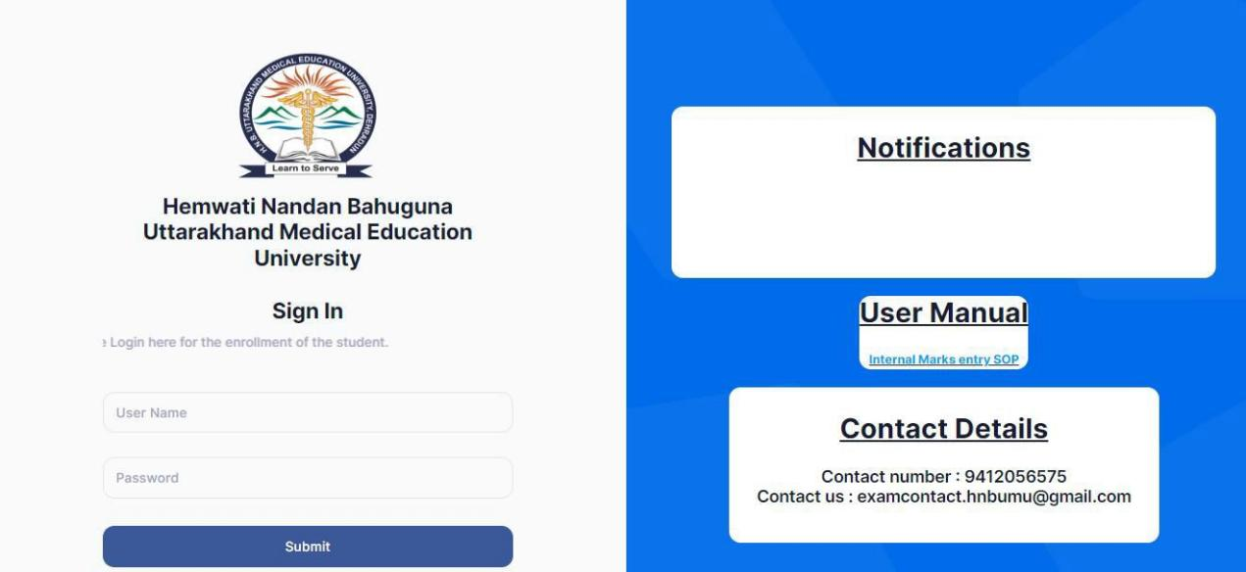

To Login kindly use the Username and Password share through mail.

STEP: 1

* Enter the Username
* Enter the Password
* Click on the submit to login STEP: 2

Once u have logged in, A screen will be open to change the password by default.

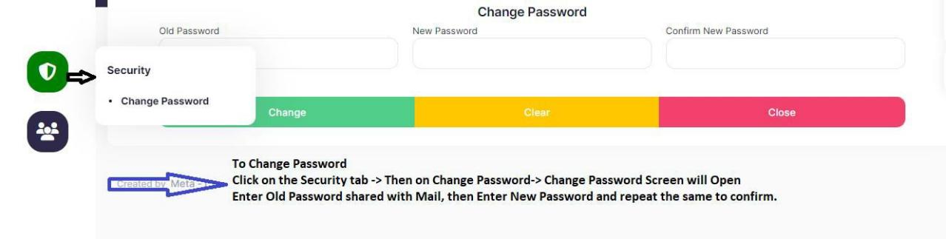

Steps to change the password is

* Click on the security tab
* Under security tab, click on Change Password
* Enter the old password (shared in mail)
* Enter the New Password of your choice
* Re Enter the new Password again
* Click on the Change icon to set new Password.

**We strongly request user to change the password.**

**Note: please set the new Password which is easy to remember and difficult to crack by unknown**

**How to begin with Registration**

1. Click on the Student Details Icon on shown on left side of the screen.

Under Student Details screen Menu, You will find the following options

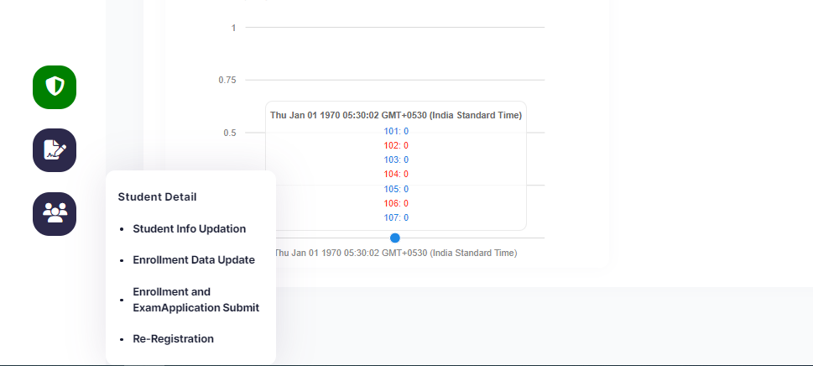

1. Student Info Updation
2. Enrollment Data Update
3. Enrollment and Exam Application Submit
4. Re-Registration

* **STEP : 1 For Registration of 3rd semester**

Click on the Student info Updation menu Student Details, upon clicking a screen will open.

1. Select the Course from Drop down list.

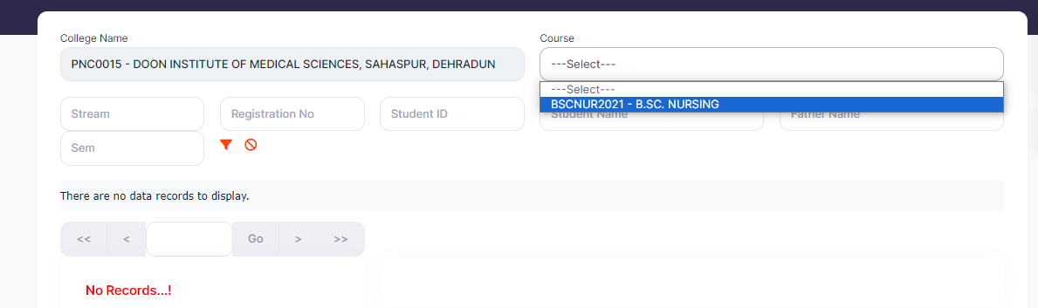

1. Upon Selecting Course, Student list will load in below grid.

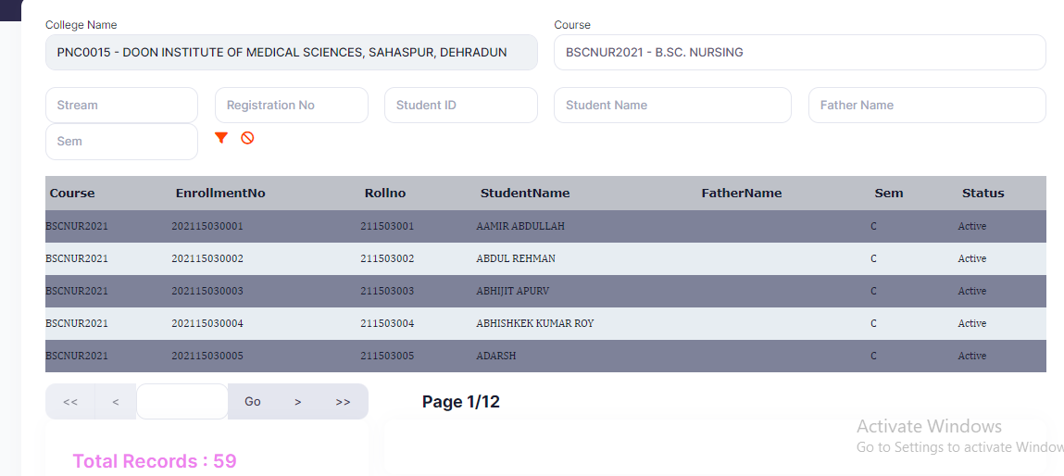

1. Click on the student to load the details of students for information upgradation.

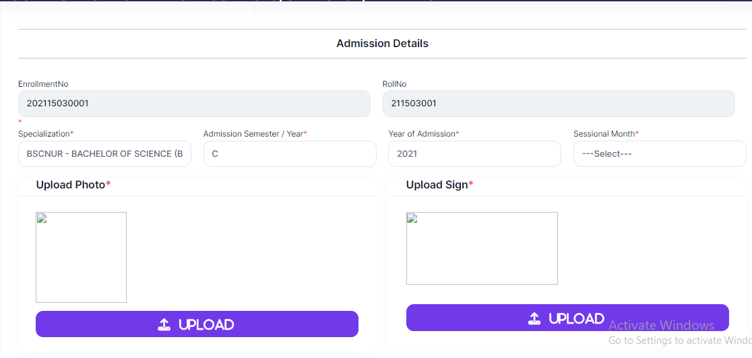

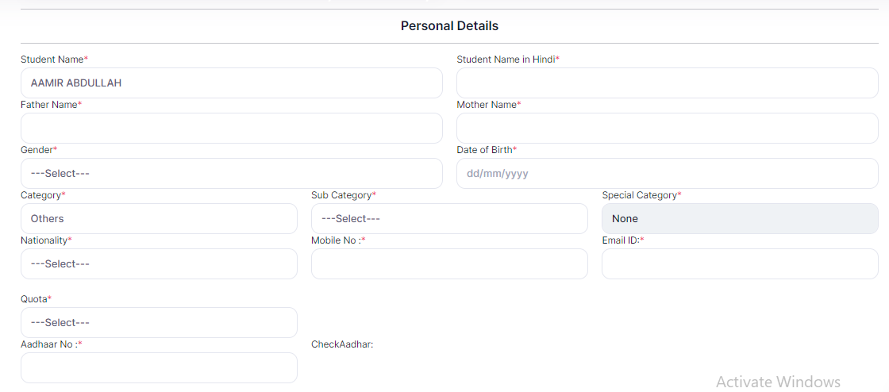

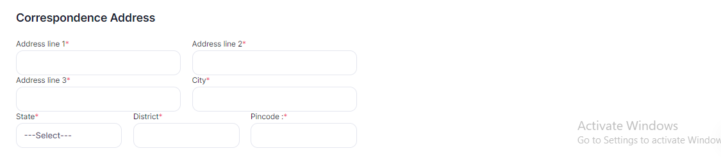

1. Once the Data is uploaded, click on to **Update Button** for save the information.



After Updating the information of all Students, lock the data

* **STEP : 2 For Re-Registration of 3rd semester Students**

Click on the Re-Registration menu under Student details

Select the options from all the fields

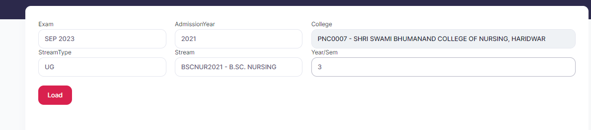

Then click on the load button.

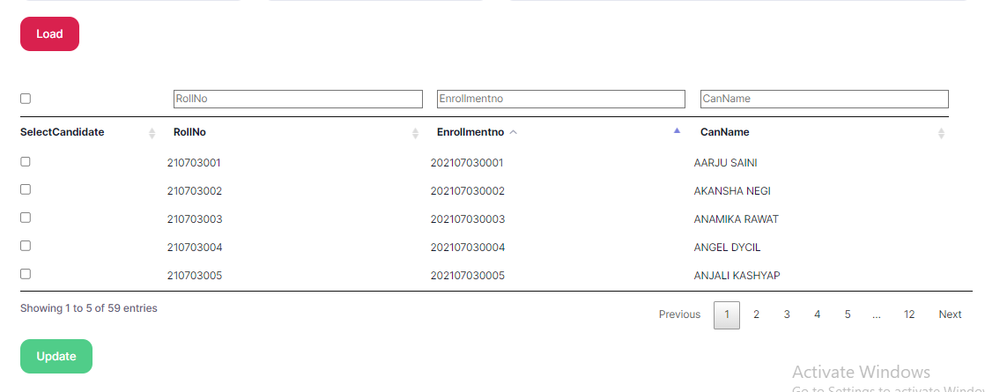

Student list will load. Select all the candidates and update.

Note: if any candidate left or changes college in middle for such candidates don’t select it.

* **STEP : 3 For Locking Registration Data of 3rd semester**

Click on the Enrollment and Exam Application Submit menu for data locking.

Select the required fields I.e Stream, course, Type of application, semester.

Select the Development fees

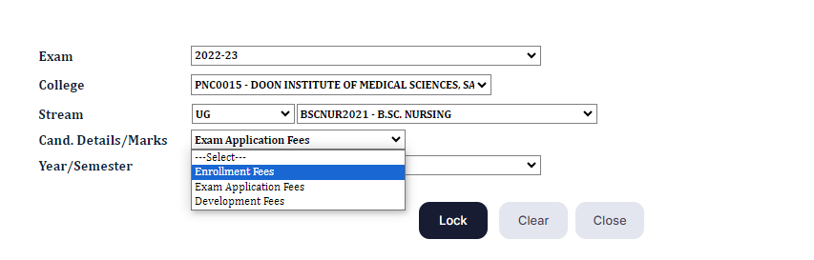

And then click on **LOCK button** to lock it.

* **STEP : 4 Challan Details for 3rd semester**

Click on the Challan Details Under Challan option.

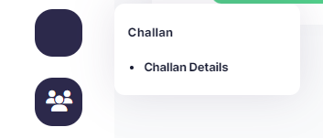

Select the on the record shown in the grid.

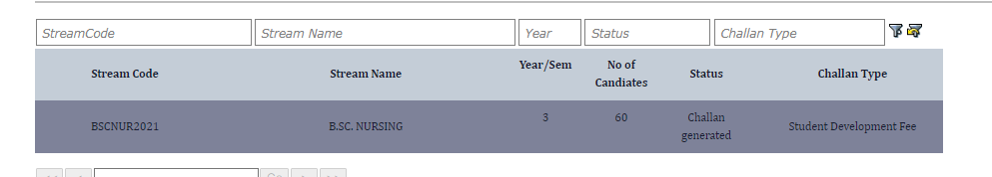

Upon clicking details information will load.

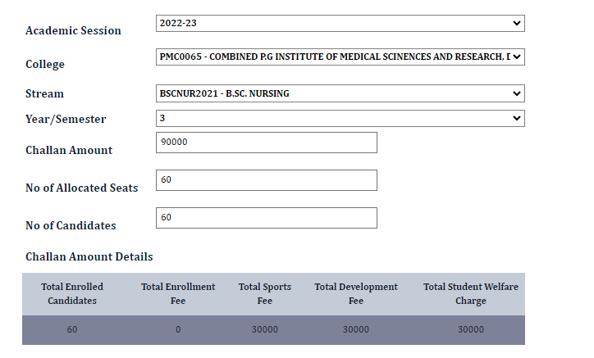

Click on download challan option to download the challan.

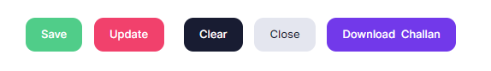

After paying the fees through NEFT, RTGS., Upload the PDF copy of Transaction slip and system generated challan on portal and save it.

